CHAPTER THREE
SYSTEM ANALYSIS AND DESIGN
This chapter describes the methodology adopted for the design and implementation of the mobile website for student continuous assessment and complaint management. It outlines the research design, system development methodology, requirements analysis, and the architectural and process models employed to guide implementation. Supporting diagrams are presented throughout to provide visual clarity on the research process, system structure, data flow, and component relationships. The combination of structured methodology and visual models ensures that the proposed system is grounded in sound academic and engineering practice.

3.1 Research Design
This study adopts a Design Science Research (DSR) methodology, which is widely recognised as appropriate for studies that involve the creation and evaluation of a new artefact in this case, a mobile web application as the primary research output (Hevner et al., 2023). DSR is characterised by its dual focus on building a functional system and rigorously evaluating it to generate knowledge that informs both theory and practice. This approach aligns with the nature of the present study, which seeks to develop a practical, deployable system while contributing to the body of knowledge on digital academic management systems in tertiary education contexts.
The research follows a structured sequence of phases: problem identification through observation and literature review; requirement elicitation from target users and institutional stakeholders; system design encompassing architectural, data, and interface models; iterative implementation of the web application; and evaluation through functional testing and usability assessment. This sequential yet iterative approach ensures that design decisions are grounded in real-world needs and that the system is continuously refined in response to findings from each phase.
Quantitative data in the form of usability scores and test results complement the artefact development, providing an objective basis for evaluating the effectiveness and acceptance of the system.

3.2 Research Methodology Framework
Figure 3.1 illustrates the overall research methodology framework adopted for this study. The framework depicts the sequence of activities undertaken from the initial identification of the research problem through to the evaluation and documentation of results. Each phase informs the next, creating a structured and traceable research process.

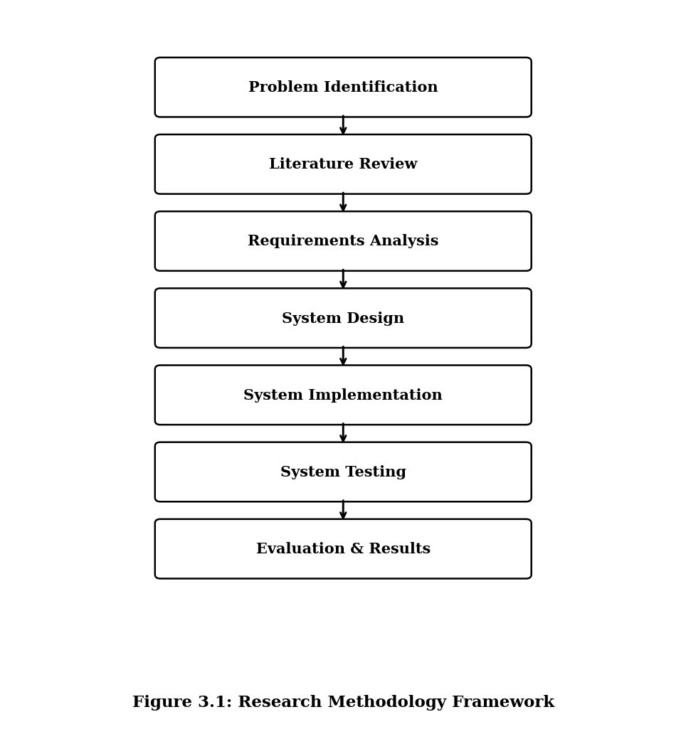
Figure 3.1: Research Methodology Framework
The framework begins with Problem Identification, where the deficiencies of existing manual continuous assessment and complaint management processes in tertiary institutions were established through observation and preliminary interviews. The Literature Review phase, covered in Chapter Two, provided theoretical grounding and identified gaps that the proposed system is designed to address. Requirements Analysis involved gathering functional and non-functional system requirements from students, lecturers, and administrative staff. System Design produced the architectural, use-case, flowchart, and data models presented in this chapter. System Implementation translated the design models into a working mobile web application. System Testing involved functional, integration, and usability testing to validate the system against its requirements. Finally, Evaluation and Results, documented in Chapter Four, assessed the system's performance and user acceptance.

3.3 Conceptual Framework
The conceptual framework in Figure 3.2 models the key entities involved in the proposed system and illustrates how inputs are processed to produce meaningful outputs for each user category. It establishes the theoretical relationships between data inputs, system processing functions, and system outputs that underpin the system design.

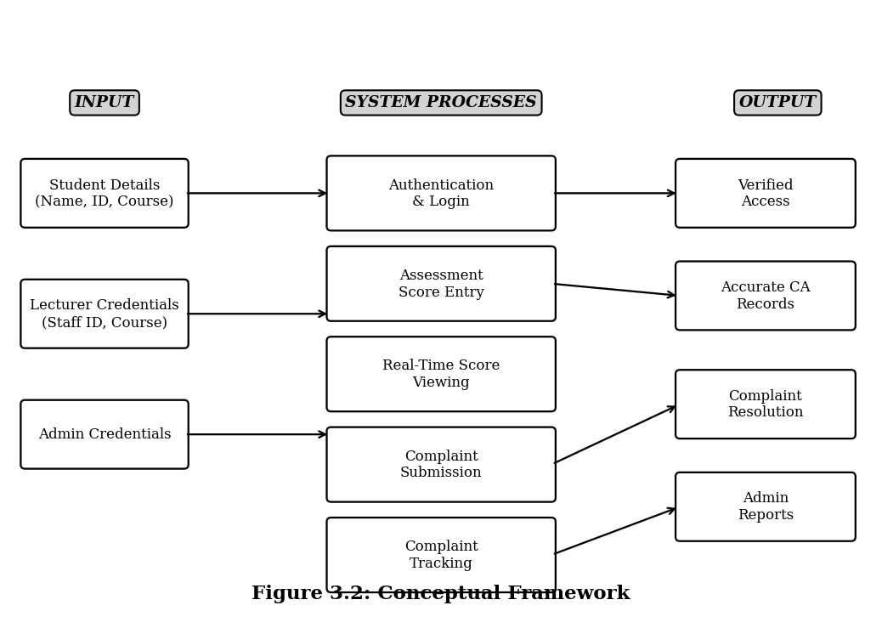
Figure 3.2: Conceptual Framework of the Proposed System
As shown in Figure 3.2, the system receives three categories of input corresponding to its three user roles. Student inputs include registration details and login credentials, which the system uses to authenticate identity and personalise the student dashboard. Lecturer inputs include staff credentials and continuous assessment score data, which are processed through the Assessment Management Module to produce accurate, auditable grade records. Administrator inputs enable system-wide oversight, complaint management escalation, and report generation.
The system processes these inputs through five core modules: Authentication and Login, Assessment Score Entry, Real-Time Score Viewing, Complaint Submission, and Complaint Tracking. These processes produce four key outputs: Verified User Access, which controls what each role can view and perform; Accurate CA Records, which constitute the authoritative store of student assessment data; Complaint Resolution, which documents the outcomes of academic grievance procedures; and Admin Reports, which support institutional decision-making and accountability. This input-process-output model directly informs the modular architecture described in Section 3.5.

3.4 System Requirements Analysis
Requirements analysis was conducted through a combination of structured interviews with three lecturers and five students from the target institution, a review of the institution's existing manual assessment administration procedures, and a survey of related system specifications drawn from the literature review. The requirements were categorised as functional and non-functional.

3.4.1 Functional Requirements
The following functional requirements were identified for the system:
- FR1: The system shall allow students, lecturers, and administrators to register and log in using unique credentials, with sessions managed securely.
- FR2: Lecturers shall be able to enter, edit, and submit continuous assessment scores for students enrolled in their courses.
- FR3: Students shall be able to view their continuous assessment scores in real time after scores have been approved and released by a lecturer.
- FR4: Students shall be able to submit formal academic complaints, specifying the course, assessment concerned, and a description of the grievance.
- FR5: Students shall be able to track the status of submitted complaints through defined stages: Submitted, Under Review, Resolved, and Closed.
- FR6: Lecturers and administrators shall be able to view and respond to complaints assigned to them within the system.
- FR7: The system shall provide an administrative dashboard displaying summary statistics for assessments, complaints, and user activity.
- FR8: The system shall generate downloadable reports on assessment scores and complaint resolution performance.
- FR9: The system shall maintain a full audit trail of all data creation, modification, and deletion events.

3.4.2 Non-Functional Requirements
The following non-functional requirements were established:
- NFR1 – Usability: The system interface shall be intuitive and navigable within three steps for core functions, and shall score at least 70 on the System Usability Scale (SUS).
- NFR2 – Responsiveness: The interface shall render correctly on mobile screens from 4 inches upward and on standard desktop browsers without horizontal scrolling.
- NFR3 – Performance: Core pages shall load within three seconds on a standard 3G mobile connection.
- NFR4 – Security: All data transmissions shall be encrypted using HTTPS; passwords shall be stored as salted hashes; session tokens shall expire after 30 minutes of inactivity.
- NFR5 – Reliability: The system shall achieve at least 99 percent uptime during examination and assessment periods.
- NFR6 – Scalability: The system architecture shall support a minimum of 2,000 concurrent users without performance degradation.
- NFR7 – Maintainability: The codebase shall follow modular design principles to facilitate future feature additions and bug fixes.

3.4.3 Technology Stack
Based on the requirements analysis and a review of technologies used in comparable systems, the following technology stack was selected for the development of the proposed system. Table 3.1 presents the selected tools and their justifications.

Table 3.1: Selected Technology Stack
Component | Technology | Version | Justification
Frontend | HTML5, CSS3, JavaScript | ES2022 | Standard web technologies ensuring broad browser compatibility and no installation requirement.
CSS Framework | Bootstrap | 5.3 | Mobile-first responsive grid system; reduces development time for responsive layouts.
Backend | Node.js with Express.js | 18.x / 4.x | Lightweight, non-blocking server suitable for real-time data handling; widely supported.
Database | MySQL | 8.0 | Relational DBMS providing structured data integrity, foreign key constraints, and audit support.
Authentication | JSON Web Tokens (JWT) | Latest | Stateless authentication suitable for mobile web contexts; pairs with HTTPS for security.
Hosting | Cloud VPS (Linux) | Ubuntu 22.04 | Low-cost, scalable deployment environment appropriate for institutional use.
Version Control | Git / GitHub | Latest | Industry-standard source code management enabling iterative development and rollback.

3.5 System Architecture
The proposed system adopts a three-tier client-server architecture, which separates the application into three distinct functional layers: the Client Tier, the Application Tier, and the Data Tier. This architectural pattern is widely recognised in educational information systems for its modularity, maintainability, and support for web-based deployment (Oghenekaro et al., 2023). Figure 3.3 illustrates the architecture.

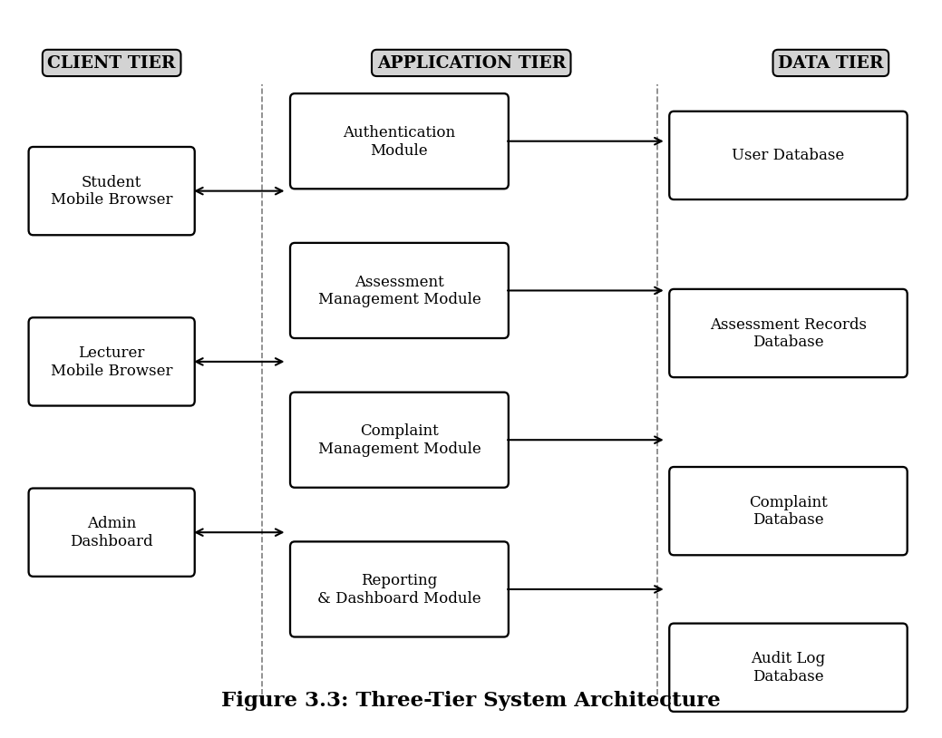
Figure 3.3: Three-Tier System Architecture
The Client Tier consists of the browser-based interfaces through which students, lecturers, and administrators interact with the system. Because the application is implemented as a mobile-responsive website rather than a native application, users access the system through any modern mobile or desktop browser without installation. The Bootstrap-based responsive frontend ensures consistent rendering across device screen sizes.
The Application Tier contains the server-side logic implemented using Node.js and Express.js. This tier is divided into four functional modules: the Authentication Module, which manages user registration, login, session management, and role assignment; the Assessment Management Module, which handles score entry, editing, approval, and retrieval; the Complaint Management Module, which processes complaint submissions, status updates, and responses; and the Reporting and Dashboard Module, which generates summary statistics and downloadable reports for administrators. Each module communicates with the Data Tier through a secure API layer.
The Data Tier consists of four MySQL databases: the User Database, which stores authentication credentials and role information; the Assessment Records Database, which stores all continuous assessment entries with version history; the Complaint Database, which stores complaint submissions and resolution records; and the Audit Log Database, which records all data modification events for accountability and dispute resolution purposes. All inter-tier communications are encrypted using HTTPS.

3.6 Use Case Diagram
Figure 3.4 presents the use case diagram for the proposed system, illustrating the interactions between the three user actors Student, Lecturer, and Administrator and the core system functions. The system boundary delineates the scope of the mobile website.

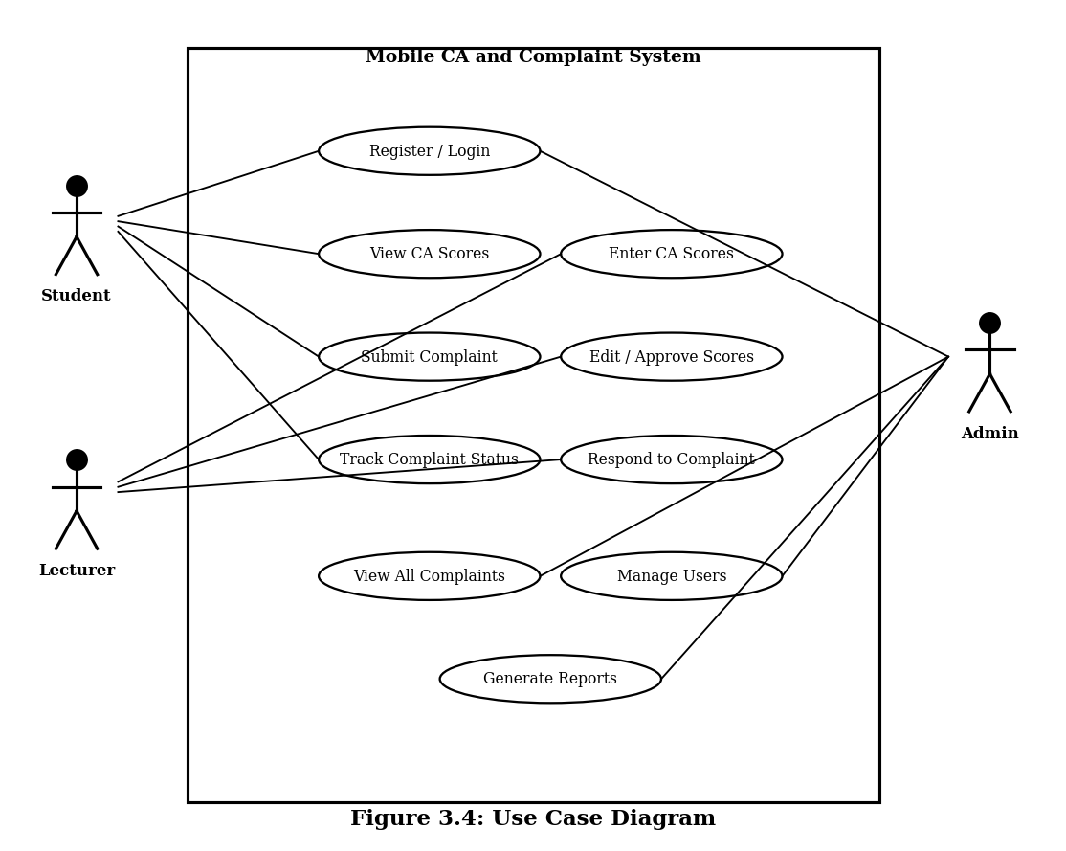
Figure 3.4: Use Case Diagram
The Student actor interacts with four primary use cases: Register/Login, View CA Scores, Submit Complaint, and Track Complaint Status. The Student can only view their own scores and complaints, enforced through role-based access control. The Lecturer actor interacts with three use cases: Enter CA Scores, Edit/Approve Scores, and Respond to Complaint. Lecturers have write access to assessment records for their assigned courses and can only see complaints related to those courses. The Administrator actor interacts with all use cases, including Manage Users, View All Complaints, and Generate Reports, and has the highest level of access within the system. The Register/Login use case is shared by all three actors as an entry point to the system, with the role determined at registration and verified at each login.

3.7 System Process Flowchart
Figure 3.5 presents the system process flowchart, which traces the sequence of operations from the moment a user opens the mobile website through to session termination. The flowchart captures the decision points involved in authentication, role-based routing, data operations, and session management.

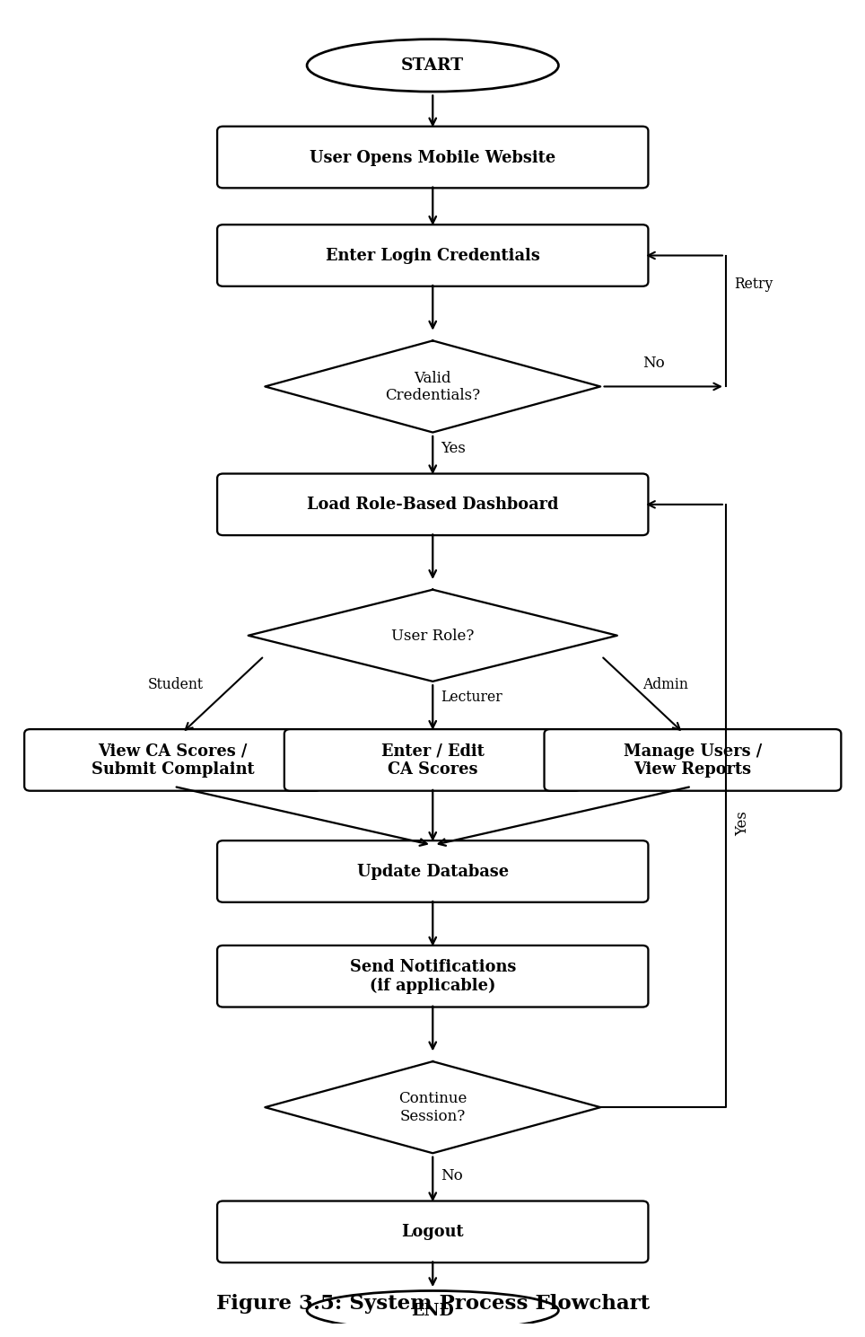
Figure 3.5: System Process Flowchart
The process begins when a user opens the mobile website and is directed to the login screen. After entering credentials, the system validates the username and password against the stored hashed values. If authentication fails, the user is prompted to retry; repeated failures trigger an account lockout after three unsuccessful attempts as a security measure. Upon successful authentication, the system retrieves the user's assigned role and loads the corresponding dashboard. The role determines the menu options and data access rights available to the user for the remainder of the session.
Students are routed to a dashboard displaying their course-specific CA scores and any previously submitted complaints. Lecturers are routed to a dashboard listing their assigned courses and pending score submissions or complaint responses. Administrators access a system-wide overview with user management and reporting functions. All user actions that modify data such as score entry, complaint submission, or status updates are processed through the application tier, persisted to the database, and logged in the audit trail. Notifications are triggered where applicable, such as when a complaint status changes or when scores are approved and made visible to students. The session continues until the user explicitly logs out or the session token expires due to inactivity.

3.8 Database Design and Entity-Relationship Diagram
The database design for the proposed system is based on the relational model, using MySQL as the database management system. The schema was designed to ensure data integrity, referential consistency, and support for audit trail functionality. Figure 3.6 presents the Entity-Relationship (ER) diagram illustrating the key entities, their attributes, and the relationships between them.

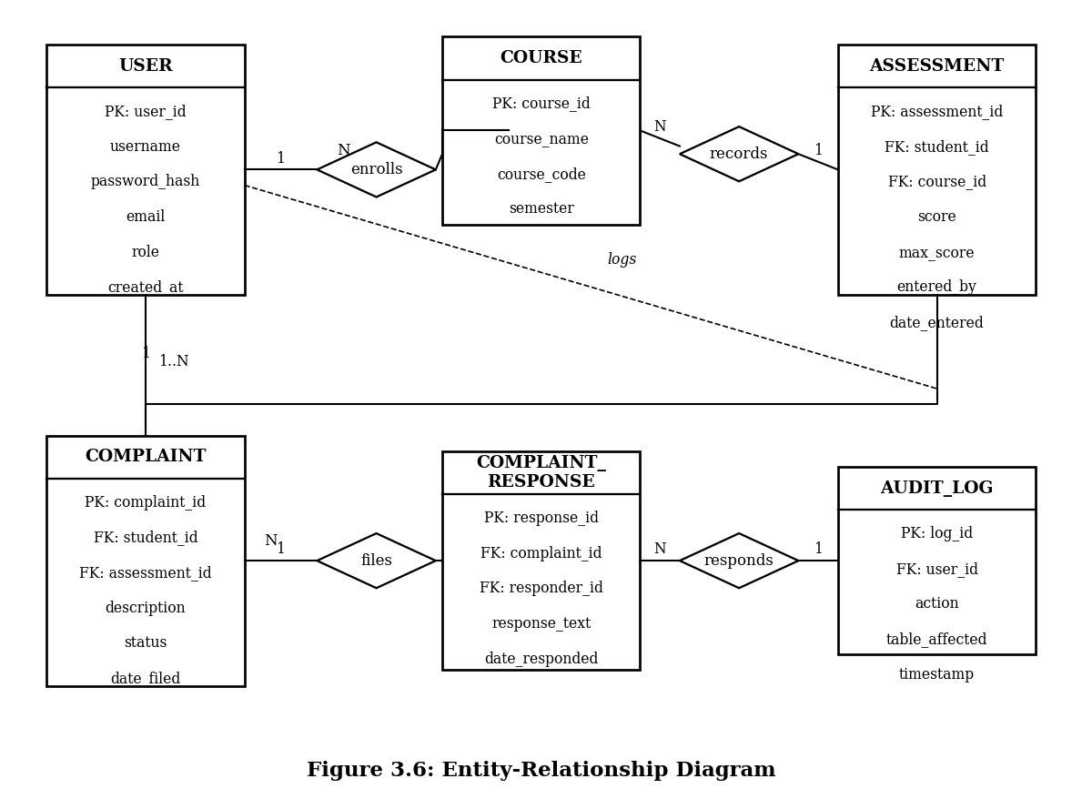
Figure 3.6: Entity-Relationship Diagram
The USER entity is central to the schema and stores authentication and role information for all system users. The role attribute distinguishes between student, lecturer, and administrator, and this value is referenced throughout the system for access control decisions. The COURSE entity stores information about each academic course offered in the institution, including the course code, name, and semester.
The ASSESSMENT entity represents individual continuous assessment records. Each assessment record is associated with a specific student (via student_id) and a specific course (via course_id), and records the score entered by the lecturer (via entered_by). This structure ensures that every score is traceable to the lecturer who entered it, satisfying the audit requirement. The COMPLAINT entity represents student-submitted grievances, each linked to a student and optionally to a specific assessment record to allow complaint handlers direct access to the relevant score data.
The COMPLAINT_RESPONSE entity records responses issued by lecturers or administrators to complaints, with a foreign key referencing both the complaint and the responder. This supports multi-round dialogue between students and complaint handlers. The AUDIT_LOG entity records all data modification events across the system, including the user responsible, the action taken, the table affected, and a timestamp. This log is write-once and accessible only to administrators, ensuring the integrity of the accountability trail.

3.9 Interface Design
The interface design of the proposed mobile website follows the mobile-first design principle, in which layouts are first optimised for small screens and progressively enhanced for larger displays. Bootstrap 5.3 is used as the primary CSS framework, providing a responsive twelve-column grid system, pre-built navigation components, and accessible form elements that reduce development effort while ensuring cross-browser and cross-device compatibility.
The colour scheme and typography are kept minimal and high-contrast to ensure readability on mobile screens under varying lighting conditions. Navigation is structured around a collapsible menu accessible via a hamburger icon on small screens and a persistent horizontal navigation bar on larger screens. Each user role is assigned a distinct dashboard landing page, ensuring that the most relevant actions are immediately visible upon login without requiring additional navigation.
Key interface screens include: the Login Screen, which presents a clean credential entry form with a forgot-password link; the Student Dashboard, which displays a summary of CA scores per course and a shortcut to submit a complaint; the Score Entry Form, which provides lecturers with a tabular interface for entering and saving scores for each enrolled student; the Complaint Submission Form, which guides students through a structured input process for documenting grievances; and the Administrator Dashboard, which presents summary statistics, pending complaints, and report generation controls.
All forms include client-side validation to provide immediate feedback before submission, and all data submission endpoints include server-side validation as a secondary security layer. Error messages are displayed inline and written in plain language accessible to non-technical users.

3.10 Chapter Summary
Chapter Three presented the methodology and system design for the mobile website for student continuous assessment and complaint management. The chapter began by establishing the Design Science Research methodology as the guiding research framework, followed by a visual Research Methodology Framework (Figure 3.1) that traced the sequence of research activities from problem identification to results evaluation.
The Conceptual Framework (Figure 3.2) illustrated the relationships between user inputs, system processing modules, and system outputs, providing a high-level model of how the proposed system fulfils its objectives. Functional and non-functional requirements were systematically identified through stakeholder engagement and a review of existing systems, and a technology stack was selected based on these requirements (Table 3.1).
The three-tier System Architecture (Figure 3.3) separated the system into client, application, and data layers, ensuring modularity and maintainability. The Use Case Diagram (Figure 3.4) defined the scope of interaction for each user role, while the System Flowchart (Figure 3.5) traced the step-by-step logic of system operation from login to session termination. The Entity-Relationship Diagram (Figure 3.6) formalised the database schema, establishing the entities, attributes, and relationships that underpin the system's data management capabilities. The chapter concluded with an overview of the interface design principles adopted to ensure usability and mobile accessibility. The designs and models presented in this chapter provide the foundation for the system implementation and testing activities described in Chapter Four..

